REACTIVE STIMULATOR (RS)

INPUT FACTORS
Stance: Volatile, quickly changeable
Content: Low tolerance for detail
Situation: Sensitive to external factors (e.g.,audience, distractions)
Patience: Very low
Attention span: Very short
Pacing: Fast and focused (sees near-term results vividly)

PROCESSING FACTORS
Memory: Relatively forgetful
Thinking Pattern: Random within a result focus
Focus: Central aspects purposefully defined
Justification: Little need or value
Consistency: Low need
Success: Volume of positive results
Urgency: High, feels a need to finish things quickly
Misunderstanding: High exposure
Transparency: High, “in your face” visibility
Risk: High tolerance
OUPUT FACTORS
Direction: Immediate action
Authority: Low deference, tends to ignore rules
Bearing: Emphatic, certain, definitive
Judgements: Explicit and direct
Delivery: Nonlinear and somewhat disjointed
Completeness: Uneven but usually incomplete
Modulation: Emotional, emphatic, excitable
Follow-up: High and frequent

HYPOTHETICAL ANALYZER (HA)

INPUT FACTORS
Stance: Stable, distant, attentive
Content: Wants relationship detail (e.g., what causes what)
Situation: Moderate sensitivity to external factors
Patience: High (but will not show when it is exhausted)
Attention span: Long
Pacing: Methodical, consistent, expansive (sees implications)
PROCESSING FACTORS
Memory: Strong “what relates to what” based memory
Thinking Pattern: Sequential, linear and expansive
Focus: Interactions, how things “fit” together
Justification: High need, wants to know it is true
Consistency: High need, things must fit into systems
Success: Depth of understanding
Urgency: Low, understanding superceeds action
Misunderstanding: Low probability
Transparency: Moderate, uses subtle signals
Risk: Minimizes but accepts
OUPUT FACTORS
Direction: Focuses on judgements, insights, plans
Authority: Moderate, “bends” rules rather than breaks
Bearing: Civilized, measured, poised
Judgements: Tentative and cautious
Delivery: Linear, consistent, logical
Completeness: Thourogh assessment (action can be incomplete)
Modulation: Rationally objective, “understanding”
Follow-up: Occasional and measured

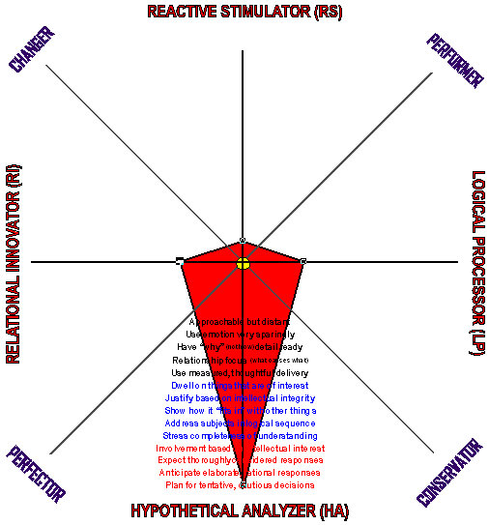
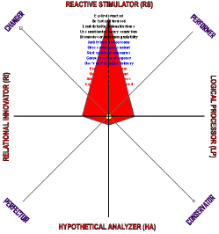

CHEAT SHEET (RS)

INPUT FACTORS
Stance: Choose timing carefully. Approachable but volatile.
Content: Use summary level approach moving to detail only if invited. Use emotion to express conviction.
Situation: Choose carefully. Easily distracted and sensitive to external factors (e.g, audiences, other input sources, etc.).
Patience: Keep elaboration to a minimum.
Attention span: Plan for less time than you expect.
Pacing: Quickly pace your presentation.
PROCESSING FACTORS
Memory: Do not rely on memory, Build in “reminders.”
Pattern: Expect to proceed in a erratic manner.
Focus: Adopt a laser focus on action-oriented results.
Justification: Minimize. The results are the “why.”
Consistency: Do not worry about fit with other things.
Success: Focus on speed and volume of positive results.
Urgency: Almost everything is a pressing matter
Misunderstanding: Be clear and simple. Reinforce.
Transparency: Read the “mood” and adjust accordingly.
Risk: Willingly accepts risk.
OUPUT FACTORS
Output: Expect a focus on “when.”
Authority: Will act “against the rules.”
Posture: Prepare for direct, emphatic and forceful bearing.
Judgements: Expect a definitive, unqualified response.
Format: Can be erratic, non-linear and undisciplined.
Completeness: Do not expect everything to be covered.
Delivery: Expect emotion, sometimes strong.
Follow-up: Anticipate follow-ups to an initiative. Tends to be impatient with negative variation. Can be severe.
CHEAT SHEET (HA)

INPUT FACTORS
Stance: Expect cordiality but do not view this as acceptance.
Content: Build on accepted theories and systems. Go into detail on “why” of your position.
Situation: Can be distracted. Mimize by capturing interest.
Patience: It is better to be thorough than quick.
Attention span: Plan to use more time than you expect.
Pacing: Use conistent, methodical and moderate pace.
PROCESSING FACTORS
Memory: Rely on memory of systems, plans & relationships.
Pattern: Expect to proceed in a logical, sequential manner.
Focus: Use “what causes what” from start to conclusion.
Justification: Offer evidence supporting your position.
Consistency: Show compatibility with other things.
Success: Stress degree of understanding and confidence.
Urgency: Almost nothing is a pressing matter.
Misunderstanding: Will ask if does not understand.
Transparency: Subtle “mood” changes can be read.
Risk: Low ris is acceptable but not welcomed.
OUPUT FACTORS
Output: Expect a focus on plans/evaluations.
Authority: Relucant to violate rules.
Posture: Prepare for questions on how things fit together.
Judgements: Expect caution and qualifications.
Format: Linear, measured and disciplined.
Completeness: Plans and asssemssets will be complete.
Delivery: Expect a rational, logical, objective response
Follow-up: Expect some but minimal follow-ups. Will accept well-reasoned explanations for variation.
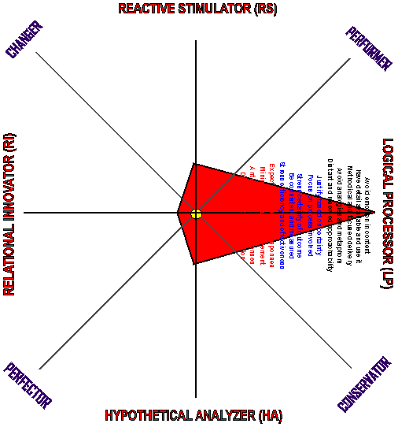
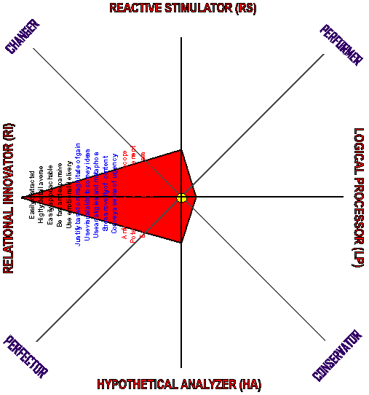
LOGICAL PROCESSOR (LP)

INPUT FACTORS
Stance: Distant, dispassionate, judicial
Content: Wants detailed “facts” (i.e., hard data, verifiable)
Situation: Insensitive to distractions, able to focus intently
Patience: Tolerant but impatient with the irrelevant
Attention span: VERY long
Pacing: Measured, deliberate, methodical
PROCESSING FACTORS
Memory: Fact based memoryVERY Long
Thinking: Prefers sequential, one thing at a time
Focus: Process based, narrow scope (e.g., what “is”)
Justification: High, wants to know things are true/accurate
Consistency: High, things should fit into processes
Success: Perfection and reliability in execution
Urgency: Low to moderate, but respects deadlines
Misunderstanding: Low probability but may miss intent
Transparency: VERY low, “inscrutable”
Risk: Very low tolerance
OUPUT FACTORS
Direction: Focus on certain, high quality, tangible results
Authority: High respect, tends to obey rules to the letter
Bearing: Dutiful, diligent, restrained
Judgements: Explicit, restrained, measured and firm
Delivery: Linear , thorough, emotionless
Completeness: Usually complete operational specificaton
Modulation Rational, objective, dispassionate
Follow-up: Low and infrequent
RELATIONAL INNOVATOR (RI)

INPUT FACTORS
Stance: Intense, interested, involved
Content: Low tolerance for detail (wants central ideas)
Situation: Easily distracted.
Patience: Uneven, depends of level of interest
Attention span: Varies by interest but overall short
Pacing: Fast and expansive (sees implicationsand extensions)
PROCESSING FACTORS
Memory: Selectively forgetful (based on interest)
Thinking: Erratic, frequently shifts between subjects
Focus: Central aspects, wide scope (e.g., what might be)
Justification: Minimal need or interest
Consistency: Low need, tend to view things on their own
Success: Degree of creativity, impact of the result
Urgency: Varies by interest-high to neglectful
Misunderstanding: High exposure
Transparency: High, almost naïve honesty
Risk: Very high tolerance (may not even see risk involved)
OUPUT FACTORS
Direction: Focuses on ideas, alternatives, options
Authority: Very low, tends not to even notice rules
Bearing: Open, honest, forthright
Judgements: Explicit but can change quickly
Delivery: Nonlinear, expansive, emotional
Completeness: Uneven-depends on interest
Modulation: Emotional, enthusiastic, committed
Follow-up: High but of short duration
CHEAT SHEET (LP)

INPUT FACTORS
Stance: Timing is flexible, but expect an aloof stance.
Content: Use extensive detail. Be completely prepared with “facts” and documented evidence.
Situation: Choose timing based on opportunity. Is relativelyinsensitive to external factors (i.e., distractions).
Patience: Do not worry about losing attention.
Attention span: Plan for long sessions.
Pacing: Use a subdued and methodical pace.
PROCESSING FACTORS
Memory: Detailed facts will be remembered completely.
Pattern: Expect focused, linear and concentrated attention.
Focus: Stay on subject, stress detailed processes involved.
Justification: Extensively prepare facts and hard evidence.
Consistency: Wants processes to “fit” existing practices.
Success: The quality, efficiency and certainty of results.
Urgency: Will get uncomfortable with tight deadlines.
Misunderstanding: Make sure your intent is clear.
Transparency: Follow logic, not mood “signals”
Risk: Very sensitive to risk. The smaller the risk , the better.
OUPUT FACTORS
Output: Expect a strong focus on “how” issues.
Authority: Respects authority. Will likely “follow the rules.”
Posture: Direct and blunt approach—not hostile, just “cold.”
Judgements: Expect a delayed but definitive response.
Format: Is likely to be linear, focused and static.
Completeness: Will not forget any “how to” elements.
Delivery: Unemotional, “matter of fact” and methodical.
Follow-up:Anticipate few on-going follow-ups to an initiative. But, will not forget any commitments.
CHEAT SHEET (RI)

INPUT FACTORS
Stance: Timing is flexible, stance will be welcoming.
Content: Use summary level approach moving to detail only if invited. Use emotion to express conviction.
Situation: Choose carefully. Easily distracted and sensitive to external factors (e.g, audiences, other input sources, etc.).
Patience: Get to the point quickly. Focus on central concepts.
Attention span: Plan for diversionsand detours.
Pacing.: Quickly pace your presentation.
PROCESSING FACTORS
Memory: Do not rely on memory, Build in “reminders.”
Pattern: Will wander. Plan to return attention to the subject.
Focus: Take a broad view, stress creativity.
Justification: Do not invest heavily in a lot of justification.
Consistency: Do not worry about fit with other things.
Success: Amount of creativity and level of ultimate gain.
Urgency: Time does not weigh heavily on a strong RI.
Misunderstanding: High exposure, reinforce often.
Transparency: Read the “mood” and adjust accordingly.
Risk: Often ignores or does not recognize risk.
OUPUT FACTORS
Output: Expect a focus on “what” (i.e., the “what” to be done).
Authority: Does not notice. Will act “against the rules.”
Posture: Prepare for eager, interested and “charged” bearing.
Judgements: Will be quick, spontaneous and changeable.
Format: Will likely be expansive, non-linear and annimated.
Completeness: Expect “loose ends.”
Delivery: Expect emotional, enthusiastic and exciting output.
Follow-up: Expect frequent, supportive followups. Problems will probably be seen as challenges

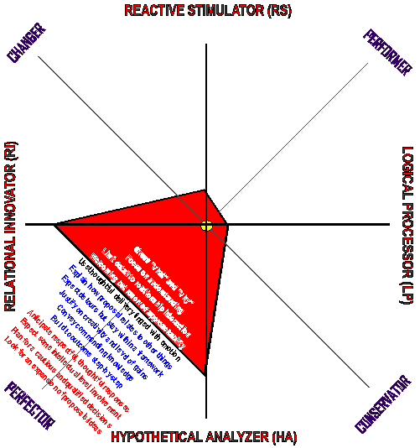
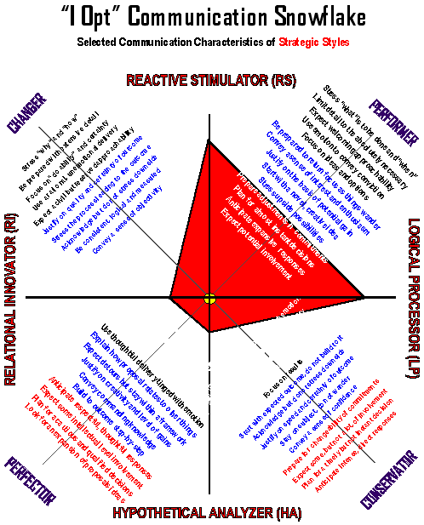
PERFECTOR (RI/HA)

INPUT FACTORS
Stance: Quiet interest
Content: Wants detail on what is affecting what
Situation: Moderately sensistive to external factors
Patience: High side of the moderate range
Attention span: Moderate, but long if fully engaged
Pacing: Measured and expansive (in both depth and scope)
PROCESSING FACTORS
Memory: Long if focused on systems, else moderate
Thinking: Prefers singular issue focus for long persiods
Focus: Depth and accuracy of understanding
Justification: High but not necessarily complete
Consistency: High but accepts some variation
Success: A thorough, compelling position
Urgency: Very low
Misunderstanding: Low exposure
Transparency: Moderate but less than complete
Risk: Low to moderate tolerance
OUPUT FACTORS
Direction: Plans, evaluations, assessments
Authority: Moderate respect, not complete submission
Bearing: Thoughtful, measured and authoritive
Judgements: Tentative, cautious, qualified
Delivery: Linear, thorogh, intellectually oriented
Completeness: Uneven, can neglect practical aspects
Modulation Restrained emotion
Follow-up: Low
PERFORMER (RS/LP)

INPUT FACTORS
Stance: Intense on action oriented issues—else indifferent
Content: Wants directly related actionable detail
Situation: If focused, insensitive to external factors
Patience: Low side of the moderate range
Attention span: Moderate for issue at hand, else low
Pacing: Narrowly focused, direct, accomodates any speed
PROCESSING FACTORS
Memory: Moderate to long
Thinking: Prefers dedicated, one thing at a time work
Focus: Measureable, tangible factors—narrow scope
Justification: Practical viability
Consistency: High within a process but otherwise low
Success: Volume and speed of results
Urgency: High with a disciplined focus on objective
Misunderstanding: Moderate but may miss inferences
Transparency: Moderate but not complete
Risk: Moderate to high. Will take chances if required
OUPUT FACTORS
Direction: Tangible results, quickly delivered
Authority: Moderate respect, not complete submission
Bearing: Determined, committed and forceful
Judgements: Explicit, direct and fast
Delivery: Linear, thorogh, practically oriented
Completeness: Uneven-can neglect implications
Modulation: Restrained emotion
Follow-up: Low to moderate

.02
CHEAT SHEET (Performer)

INPUT FACTORS
Stance: Timing is important—insensitive, purposeful posture.
Content: Have relevant detail. This will usually be action relevant with direct applicability to the issue at hand.
Situation: Sensitive to external factors (e.g. audience, distractions, etc.) but is easily focused by matters of interest.
Patience: Can be short. Be action oriented and purposeful.
Attention span: Plan for short, purposeful sessions.
Pacing: Use a brisk, but not fast, pace.
PROCESSING FACTORS
Memory: Reasonable memory of facts and circumstances.
Pattern: Expect an intense focus centering on objective.
Focus: Stay on subject, stress “how” and “when”, not “why.”
Justification: Have facts and hard evidence. Do not overdo.
Consistency: Show fit with other processes and activities.
Success Standard: Volume/speed of positive results.
Urgency: Expect high but disciplined urgency.
Misunderstanding: Be clear & direct. Can miss subtleties.
Transparency: Not fully transparent. Do not overinterpret.
Risk: Accepts reasonable risk. Will take high risk if pressed.
OUPUT FACTORS
Output: Focuses on “when” and “how” of an issue
Authority: Sensitive to authority but will “break the rules.”
Posture: Will likely be direct, blunt and challenging
Judgements: Reasonably quick, definitive reponse.
Format: Focuses on results, not detailed process.
Completeness: May miss things in the interest of speed.
Delivery: Is likely to be honest, direct and insensitive.
Follow-up:Anticipate on-going but irregular follow-ups. Can micro-manage, keep informed of progress to minimize.
CHEAT SHEET (Perfector)

INPUT FACTORS
Stance: Timing is flexible: interested, sensitive and curious.
Content: Have “why”detail ready in depth. Unlikely to be interested in “how” detail.
Situation: Moderately sensitive to external factors (e.g. audience, distractions, etc.). Balance opportunity with situation.
Patience: Inexhasustable if interested. Capture interest.
Attention span: Plan for long, elaborate sessions.
Pacing: Use a normal, measured pace.
PROCESSING FACTORS
Memory: Remembers relationships—not operating details.
Pattern: Likes to work in an unbroken streams.
Focus: Prone to wandering. Plan efforts to keep on subject.
Justification: Plan on questions and gentle challanges.
Consistency: Things should fit with prior knowledge.
Success Standard: Full understanding, complete plans.
Urgency: Expect a “laid back” but confident posture.
Misunderstanding: Can miss operational implications.
Transparency: Not fully transparent. Do not overinterpret.
Risk: Will take modest risks.
OUPUT FACTORS
Output: Focuses on “what” and “why” of issues.
Authority: Acknowledges but will “bend (not break) rules”.
Posture: Indirect, sensitive and perhaps a bit opaque.
Judgements: Takes time and tends to qualified responses.
Format: Focuses on plans/reasons/options.
Completeness: May miss “how to” considerations.
Delivery: Honest, cautious, reserved and respectful.
Follow-up: Anticipate occasional follow-ups. Expect to be watched but not pestered.

CHANGER (RS/RI)

INPUT FACTORS
Stance: Intense but variable and intermittent
Content: Low tolerance for any detail
Situation: Moderately sensitive to external factors
Patience: Low
Attention span: Short
Pacing: Direct, fast, expansive (sees added implications)
PROCESSING FACTORS
Memory: Low retension (moderate on items of interest)
Thinking: Erratic, likes to shift focus frequently
Focus: New, creative ideas that produce major gains
Justification: Low need
Consistency: Low need or value
Success: Uniqueness, creativity, e result
Urgency: High
Misunderstanding: High exposure
Transparency: High (can rely on behavioral cues)
Risk: High tolerance
OUPUT FACTORS
Direction: Focuses on tangible, creative results
Authority: Low deference, tends to ignore rules
Bearing: Interested, committed, animated
Judgements: Explicit but readily changeble
Delivery: Nonlinear, disjointed, erratic
Completeness: Uneven, usually leaves loose ends
Modulation High emotional overlay, forceful
Follow-up: High
CONSERVATOR (LP/HA)

INPUT FACTORS
Stance: Distant, objective, respectful
Content: High “how” and “why” detail
Situation: Relatively insensitive to external factors
Patience: High
Attention span: Very long
Pacing: Measured, deliberate, detailed
PROCESSING FACTORS
Memory: Very long for facts and processes (i.e., systems)
Thinking: Singular focus (does not like to jump around)
Focus: Tangible results of high quality, reliably delivered
Justification: High (for both why and how)
Consistency: High value (little, if any, variation accepted)
Success: Quality & reliability of results
Urgency: Low but respects deadlines
Misunderstanding: Low exposure
Transparency: Low (tends to hold matters private)
Risk: Low tolerance
OUPUT FACTORS
Direction: Focuses on tangible, consistent results
Authority: High deferenced, respects rules
Bearing: Dutiful, diligent
Judgements: Explicit but restrained
Delivery: Linear, thorough, logical, detailed
Completeness: High on practical aspects
Modulation Objective, dispassionate
Follow-up: Low
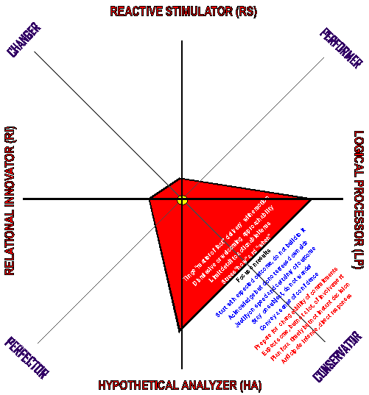
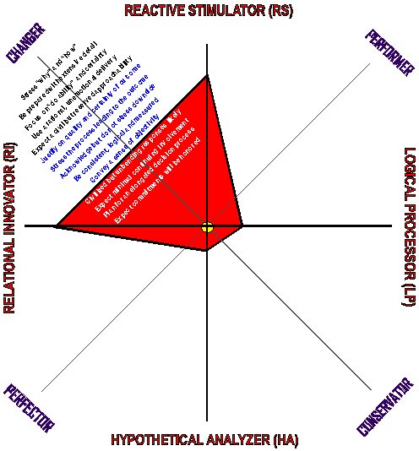
CHEAT SHEET (CONSERVATOR)

INPUT FACTORS
Stance: Expect a distant but respectful posture.
Content: Have detail on hand. Be ready to explain the “why” and “how” of any proposal or position.
Situation: Use any opportune time. Will focus completely.
Patience: Take your time, patience is very high.
Attention span: Plan long, linear sessions.
Pacing: Be deliberate, methodical and unemotional.
PROCESSING FACTORS
Memory: Be prepared to relate things to past history.
Pattern: Use a linear, single purpose approach. Do not jump.
Focus: Focus on results with “how to” process emphasis.
Justification: Invest heavily in justification.
Consistency: Stay consistent with what now exists.
Success Standard: Perfection, reliablility, efficiency.
Urgency: Focus on repeating gains, do not stress urgency.
Misunderstanding: Unlikely.
Transparency: Guarded. Do not read to much into cues.
Uncertainty: Wants NO risk.
OUPUT FACTORS
Output: Targets tangible results delivered as committed.
Authority: Unlikely to “break the rules.” Stress conformity.
Posture: Expect a dutiful and diligent bearing.
Judgements: Explicit, unqualified delivered with restraint.
Format: Expect linear, focused and thorough responses.
Completeness: Prepare for very little to be missed.
Delivery: Is likely to be blunt and unambiguous.
Follow-up: Expects that things will be done as committed. Process oversight will be minimal. Little chance to adjust.
CHEAT SHEET (CHANGER)

INPUT FACTORS
Stance: Expect open, accepting and intense posture.
Content: Avoid detail. Focus on central aspects. Use analogies and metaphors to explain.
Situation: Control the environment to minimize distraction.
Patience: Very low. Get to the point quickly.
Attention span: Tends to be short. Be succinct.
Pacing: Be direct, fast and expansive (vs narrow focus).
PROCESSING FACTORS
Memory: Short. Prepare to remind of relevant items
Pattern: Expect to bounce around.. Keep yourself on track.
Focus: Wants creativity, novelty and big gains.
Justification: Do not spend a lot of time on this unless asked.
Consistency: Do not invest heavily in showing consistency.
Success Standard: Degree of creativity, size of gain.
Urgency: Use an intense, short-term interest focus.
Misunderstanding: High. Be sure you make yourself clear.
Transparency: Open, accepting, Trust your perception.
Uncertainty: Some risk will usually readily accepted.
OUPUT FACTORS
Output: Targets tangible results of a creative character.
Authority: Tends to ignore rules. Do not stress conformity.
Posture: Expect intense, highly committed bearing.
Judgements: Expect fast, unqualified and changeable.
Format: Nonlinear, erratic, expansive but focused
Completeness: Misses things. Be sure to get all you need.
Delivery: Is likely to be enthusiastic and emotional.
Follow-up: Expect an continuing interest and involvement in activities and intiatives. You will get a chance to adjust.
✓

Stance:
Content:
Situation:
Patience:
Attention span:
Pacing:

Memory:
Thinking:
Focus:
Justification:
Consistency:
Success:
Urgency:
Misunderstanding:
Transparency:
Risk:

Direction:
Authority:
Bearing:
Judgements:
Delivery:
Completeness:
Modulation:
Follow-up:
INTERESTS OF RECIEVER

PROBABLE OUTCOMES OF RECIEVER

COMMUNICATION WORKSHEET
✓

Stance:
Content:
Situation:
Patience:
Attention span
Pacing:

Memory:
Thinking:
Focus:
Justification:
Consistency:
Success:
Urgency:
Misunderstanding:
Transparency:
Risk:

Direction:
Authority:
Bearing:
Judgements:
Delivery:
Completeness:
Modulation:
Follow-up:
INTERESTS OF RECIEVER

PROBABLE OUTCOMES OF RECIEVER

COMMUNICATION WORKSHEET
✓
Stance: This refers to the attitude or viewpoint you are likely to encounter when interacting with the reciever.
Content This is the nature of the substantive information or creative material to be delivered to the reciever.
Situation: The circumstances surrounding but not directly pertaining to the information transfer.
Patience: The ability or willingness to suppress restlessness or annoyance when dealing with delayor slow transmission.
Attention span: Amount of time a person can or is willing toconcentrate on a single activity.
Pacing: The rate or tempo of the information transmission.
Memory: The ability to retain and recall past events, facts, experiences, impressions and etc.
Thinking: The pattern, style, form or model the reciver is likely to use in manipulating the information provided for further processing.
Focus: The center of attraction, activity or attention that is likely to be used by the reciever in the transacton.
Justification: Reasons or facts that show a claim, act or statement to be just or right.
Consistency: Reasons or facts that show a claim, act or statement to be just or right.
Success: Criteria used to determine favorability of outcome.
Urgency: The degree of pressing importance of an issue.
Misunderstanding: Possibility of mistaken comprehension.
Transparency: The full, accurate and timely disclosure of information about the current state of attitude, judgement, etc.
Risk: Exposure to the chance of injury or loss.
Direction: Likely ouput line or orientation that will be used.
Authority: Willingness to follow rules or directions.
Bearing: The likely conduct displayed when transmitting.
Judgements: The nature and durability of decisions made.
Delivery: The method, tone and nature of the transmission.
Completeness: The degree that the transmission lacks something needed or desired.
Modulation: Nature/degree of stress used in transmission.
Followup: Review or monitoring of an activity or decision.
INTERESTS OF RECIEVER: This refers to the effect in terms of advantage or detriment that the reciever may incur as a result of the information received.

PROBABLE OUTCOMES OF RECIEVER
This is a condition the reciever is likely to experience if the information is processed in the manner desired.
Explanation of Terms Used
✓
Stance: This refers to the attitude or viewpoint you are likely to encounter when interacting with the reciever.
Content This is the nature of the substantive information or creative material to be delivered to the reciever.
Situation: The circumstances surrounding but not directly pertaining to the information transfer.
Patience: The ability or willingness to suppress restlessness or annoyance when dealing with delayor slow transmission.
Attention span: Amount of time a person can or is willing toconcentrate on a single activity.
Pacing: The rate or tempo of the information transmission.
Memory: The ability to retain and recall past events, facts, experiences, impressions and etc.
Thinking: The pattern, style, form or model the reciver is likely to use in manipulating the information provided for further processing.
Focus: The center of attraction, activity or attention that is likely to be used by the reciever in the transacton.
Justification: Reasons or facts that show a claim, act or statement to be just or right.
Consistency: Reasons or facts that show a claim, act or statement to be just or right.
Success: Criteria used to determine favorability of outcome.
Urgency: The degree of pressing importance of an issue.
Misunderstanding: Possibility of mistaken comprehension.
Transparency: The full, accurate and timely disclosure of information about the current state of attitude, judgement, etc.
Risk: Exposure to the chance of injury or loss.
Direction: Likely ouput line or orientation that will be used.
Authority: Willingness to follow rules or directions.
Bearing: The likely conduct displayed when transmitting.
Judgements: The nature and durability of decisions made.
Delivery: The method, tone and nature of the transmission.
Completeness: The degree that the transmission lacks something needed or desired.
Modulation: Nature/degree of stress used in transmission.
Followup: Review or monitoring of an activity or decision.
INTERESTS OF RECIEVER: This refers to the effect in terms of advantage or detriment that the reciever may incur as a result of the information received.

PROBABLE OUTCOMES OF RECIEVER
This is a condition the reciever is likely to experience if the information is processed in the manner desired.
Explanation of Terms Used

Use card stock. Fold sharply.
www.iopt.com
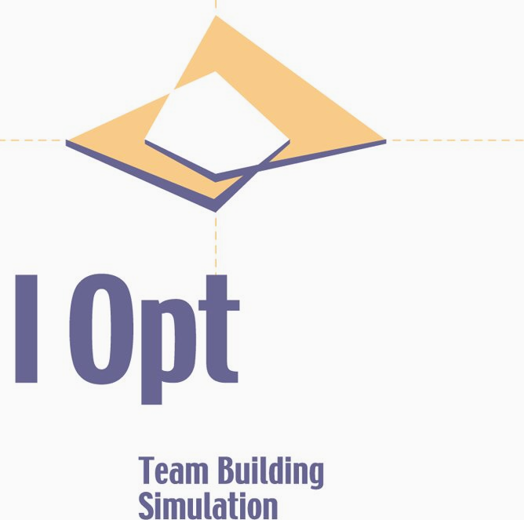
© 2008, Professional Communications, Inc. All rights reserved.

